**CS 212**

**Conclusion Report**

**Group 17**

**Jiacheng Shen shenjch18@lzu.edu.cn 320180949191**

**Ziyao Wang wangziyao2018@lzu.edu.cn 320180940361**

**Motong Tian tianmt18@lzu.edu.cn 320180940301**

**Yichen Wang ychwang2018@lzu.edu.cn 320180940341**

**Zixiang Song songzx18@lzu.edu.cn 320180940221**

**Ke Lei leik18@lzu.edu.cn 320180939861**

**Jiang Zhou zhoujiang18@lzu.edu.cn 320180940681**

**Wei Zhu zhuw2018@lzu.edu.cn 320180940701**

1. **Hypothesis**

The bugs created in kernel development would be fixed faster as time goes on.

1. **Metric**

The correlation between bug survival time and time based on line chart(as there are too many of bugs and there is little effect of line chart, we change it to histogram). The linearity and monotonicity of the diagram need to be observed.

1. **Data**

Our data is from commit log of kernel stable from v4.1 to now, extracting those commit that has ‘Fix’ tag.

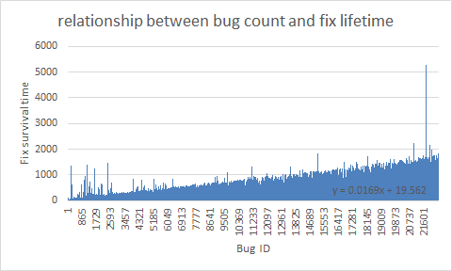

Note:The horizontal axis of the graph above shows the bug created from now to the past, the bug whose ID is 1 is the latest bug in kernel!

Characteristic:There is a linear correlation between bug survival time and bug ID, y=kx+b, k=0.0169 and b=19.562.

1. **Observation**

As it shown above, the x-axis of the histogram represents the Bug ID which was sorted by the order from the present to the past. y-axis represents how long the bug exists.

According to the metric, Bug ID and Fix survival time have the positive linear correlation, and the k=0.0169. It reflects that as time goes on (i.e. as the ID decreases), the survival time of bugs decreases.

1. **Conclusion**

Based on the result of our observation, the ability of bug fixing has improved over the development, reflecting that the quality of kernel development has become higher and higher in terms of time efficiency. The reason why this happen may be that as the time goes by, the fixers in kernel society become more, so does the ability of bug fixing. In addition, The linux OS tends to mature, while the critical bug become less and less. All of this resulted in the phenomenon as histogram showed.

While we do not draw definitive conclusions about the overall quality of kernel development, as there is a doubt that whether the decrease trend of bug fixing time is due to the inefficiency of fix? Can the fix of the bug has become arbitrary, which leads to decrease of fixing time but incomplete fix of the bug? We are still skeptical of development quality until more data is available.